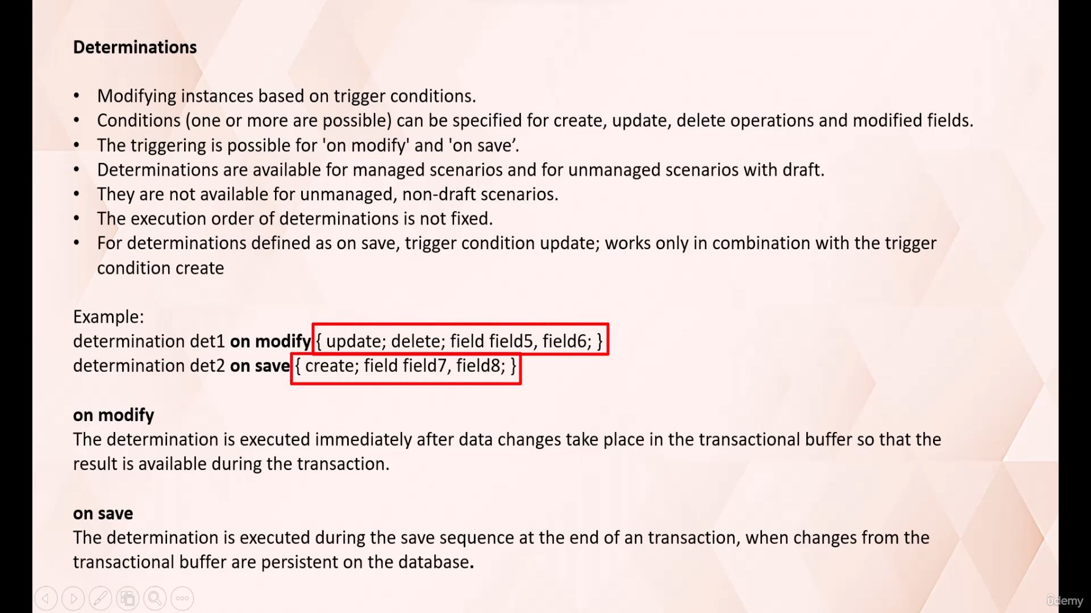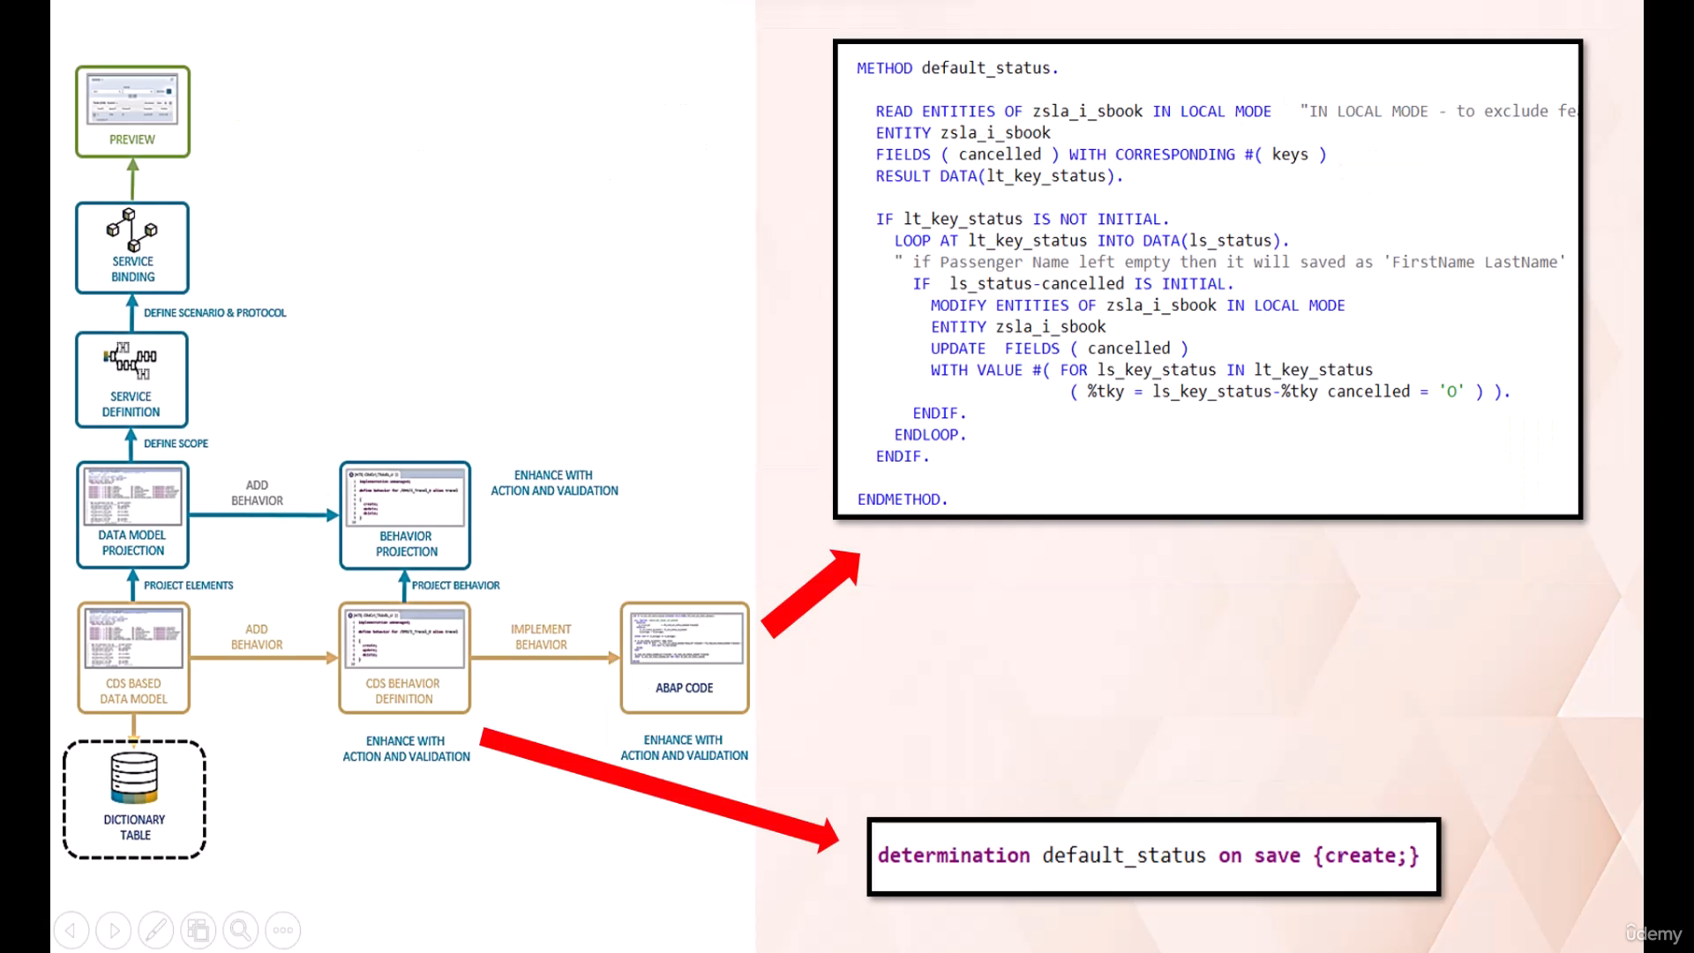In this video tutorial I will discuss with you about determinations.

A determination is an optional part of business object behavior that modifies instance of business objects

based on trigger conditions.

It is mandatory to provide at least one trigger condition within the curly brackets.

Determination is executed when an instance is created, updated, or deleted.

Determination is also executed when value of one of the specified fields is changed by create or update

operation.

A determination is implicitly invoked by Rap framework if the trigger conditions of determination is

fulfilled, the trigger condition is evaluated at trigger time.

Trigger time is a predefined point during the business Object Runtime based on trigger time.

There are two types of determination on modify and on save.

On modify, determination is executed immediately after data changes take place in the transactional

buffer, so that the result is available during the transaction.

On save, determination is executed during the save sequence at the end of an transaction, when the

changes from the transactional buffers are persistent on the database.

or determinations to trigger times are available on modify and on save.

Whereas for validations only on save, trigger time is available.

Like actions and validations, determinations are defined in behavior definition of rape.

Business object and determinations are implemented in behavior pool through dedicated method of local

handler class.

The execution order of determinations is not fixed.

If there is more than one determination triggered by the same condition, you cannot know which determination

is executed first.

It is very important part related to determination.

Determinations are available for managed scenarios and for unmanaged scenarios with draw.

They are not available for unmanaged non-draft scenarios.

In this point we have discussed about the theory related to determination.

Now let's look at one example and implement determination in system.

Let's define a determination that will be used to set default value of booking status to open at the

creation time.

New booking instance.

As you can see in this example, once the record is created in system, the booking status is by default

set to open.

For this purpose, we need to define determination in CDs behavior definition and we need to write logic

in CDs.

Behavior implementation.

Now let's go to our earlier project and add functionality for determination.

Here you need to go behavior definition.

And define determination.

Okay.

So here to define determination we needs to use keyword determination.

Then the method name.

Then we need to specify trigger time.

And then in curly bracket we need to specify trigger condition.

Now let's implement it.

Press Ctrl one.

Let's add a method.

Let's look at first the method definition.

Here you can see trigger time on save.

Importing to this method is key fails.

And now let's implement this method to save your time.

I have already written a code and I'll be using that here.

It's very simple and straightforward code here using these three DML statement.

We are reading the filled content cancel.

That is nothing but the status field in our case against the key field and collecting the result in

this internal table.

And then using this DML modify statement, we are simply updating that field.

We are updating the status field with value four.

Let's activate it first.

Okay, we got one error here.

That is because we need to activate the behavior definition first.

Okay.

Now let's activate this class.

Done.

Now let's go to our service binding.

Let's refresh it.

Let's preview the application.

Now let's click on create button.

Let's add some information here.

Okay.

And let's hit the create button.

Uh, before that, uh, since this status, we can edit here, let's make this field read only so that

during create operation, users should not be able to set the value for this status field.

For that.

We needs to use here.

We will then in bracket we needs to write read only and then field name.

Okay, now let's go back to the Fury application.

Let's reload.

And you can see here.

Now this status field is read only during create operation.

We cannot edit the value of status field.

Now let's hit the create button that we.

As you can see here, status is updated with value.

Oh once the record is created.

So with this example, we have seen how to use determination to set a default value of booking status

to open at creation time.

New booking instance.

With this example I hope you understood the working of determination.

Thank you for watching this video.

Have a nice day ahead.